Programming for Engineers-I

Lab Handout 3

**(If-Elseif)**

Today’s Topic

* Compilation Process
* Operators
* Operators Precedence
* Conditional Statement
  + If-elseif
* While Loop

**Compilation Process**

The compilation process includes the following steps:

1. The compiler translates the high level language into assembly language.
2. The assembler translates assembly language into object code.
3. The linker builds an executable program from object modules and any library modules required.

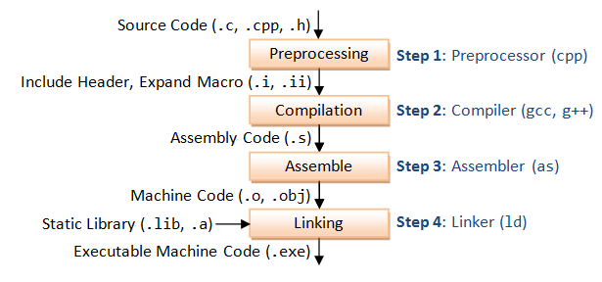

**Preprocessor:**

Conceptually, the ``preprocessor'' is a translation phase that is applied to your source code before the compiler proper gets its hands on it. (Once upon a time, the preprocessor was a separate program, much as the compiler and linker may still be separate programs today.) Generally, the preprocessor performs textual substitutions on your source code, in three sorts of ways:

* File inclusion: inserting the contents of another file into your source file, as if you had typed it all in there.
* Macro substitution: replacing instances of one piece of text with another.
* Conditional compilation: Arranging that, depending on various circumstances, certain parts of your source code are seen or not seen by the compiler at all.

Operator Precedence

Operators

Precedence

|  |  |
| --- | --- |
| Operators | Operator Types |
| ( ) | Arithmetic |
| * / % | Arithmetic |
| + - | Arithmetic |
| < <= > >= | Relational |
| == != | Equality |
| = | Assignment |

Control Statements

Every programming language provides a structure for decision making. 'C' also provides this structure. We see them one by one.

If Statement

The statement used for decisions in 'C' language is known as the '*if* statement'. The *if* statement has a simple structure. That is

*if ( condition )*

*Statement (or group of statements)*

The above statements mean, If condition is true, then execute the statement or a group of statements.

If/else-if Statement

We have seen that the *if* structure executes its block of statement(s) only when the condition is true, otherwise the statements are skipped. The if/else structure allows the programmer to specify that a different block of statement(s) is to be executed when the condition is false. The structure of if/else selection is as follows.

 if(TEST)

{  
          CODE;  
      }

else if(TEST)

{   
          CODE;  
      }

 else {  
          CODE;  
      }

**Lab Tasks**

**Q-1** Take three integers from the user and check which one is greatest.

**Q-2** Assign the grades to Prog-1 students on the bases of this criteria using if/else statement:

|  |  |
| --- | --- |
| >80 | A |
| >=70 <80 | B |
| >=60 <70 | C |
| >=50 <60 | D |
| <50 | F |
| >100 | Wrong Entry |

**Q-3** Print a menu for a Bank System:

* Deposit
* Withdraw

Take total amount form the user. Calculate the profit on the amount deposited in the bank at the rate of 10%. Also take care of the total amount… (Withdrawal amount should not increase the total amount limit)